Understand code versioning using GitHub
  - What is Git?
Git is world most popular version control system, but what does that mean? Let us take an example: While creating a project there are different files to save, it makes managing our files easier and the History. Where the word history means to get and keep the track of every change made to a project. Git can even tell the lines of code we added and which lines of code we removed; a great feature of history made work more at ease. When developers create something (an app, for example), they make constant changes to the code, releasing new versions up to and after the first official (non-beta) release.
Git made the Collaboration very easy. Version control systems keep these revisions straight, storing the modifications in a central repository. This allows developers to easily collaborate, as they can download a new version of the software, make changes, and upload the newest revision. Every developer can see these new changes, download them, and contribute.
Git has Feature Branches that helps to work on multiple features at once. Git is a command-line tool, but the center around which all things involving Git revolve is the hub—GitHub.com—where developers store their projects and network with like minded people.
  - Why to learn Git?
To bring a bit of structure and organization to your code learning git is truly a must. Git is not only for developers, people who have nothing to do with development can also use and download files from Git.

It is a preferred version control system of most developers since it has multiple benefits like History, Collaboration, Feature Branches over the other systems available. It stores file changes more efficiently and ensure file integrity better.
To know more go to, the Git Basics page has a thorough explanation on how Git works.
Let us go over a few of the main reasons that geeks like to use GitHub and learn some terminology along the way.

Repository
A repository (usually abbreviated to “repo”) is a location where all the files for a particular project are stored. Each project has its own repo, and you can access it with a unique URL.
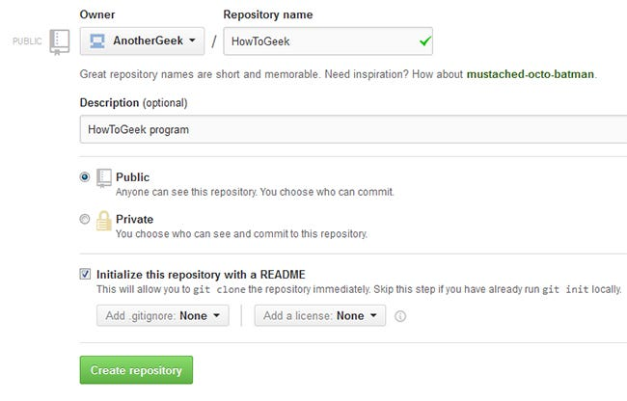

Forking a Repo
“Forking” is when you create a new project based off, of another project that already exists. This is an amazing feature that vastly encourages the further development of programs and other projects. If you find a project on GitHub that you would like to contribute to, you can fork the repo, make the changes you’d like, and release the revised project as a new repo. If the original repository that you forked to create your new project gets updated, you can easily add those updates to your current fork.

Pull Requests
You’ve forked a repository, made a great revision to the project, and want it to be recognized by the original developers—maybe even included in the official project/repository. You can do so by creating a pull request. The authors of the original repository can see your work, and then choose whether to accept it into the official project or not.
Whenever you issue a pull request, GitHub provides a perfect medium for you and the main project’s maintainer to communicate.

Social networking
The social networking aspect of GitHub is probably its most powerful feature, allowing projects to grow more than just about any of the other features offered. Each user on GitHub has their own profile that acts like a resume of sorts, showing your past work and contributions to other projects via pull requests.
Project revisions can be discussed publicly, so a mass of experts can contribute knowledge and collaborate to advance a project forward. Before the advent of GitHub, developers interested in contributing to a project would usually need to find some means of contacting the authors—probably by email—and then convince them that they can be trusted, and their contribution is legit.

Changelogs
When multiple people collaborate on a project, it is hard to keep track revisions—who changed what, when, and where those files are stored. GitHub takes care of this problem by keeping track of all the changes that have been pushed to the repository.
  - Let’s get started with a small lab on using VS Code with GitHub.
Now that you know what GitHub is all about, are you ready to get started?
Installation of Git on your running machines
Step 1: To download and install git on your running machines, click here https://git-scm.com/downloads ,choose the right version – windows, macOS and linux. | 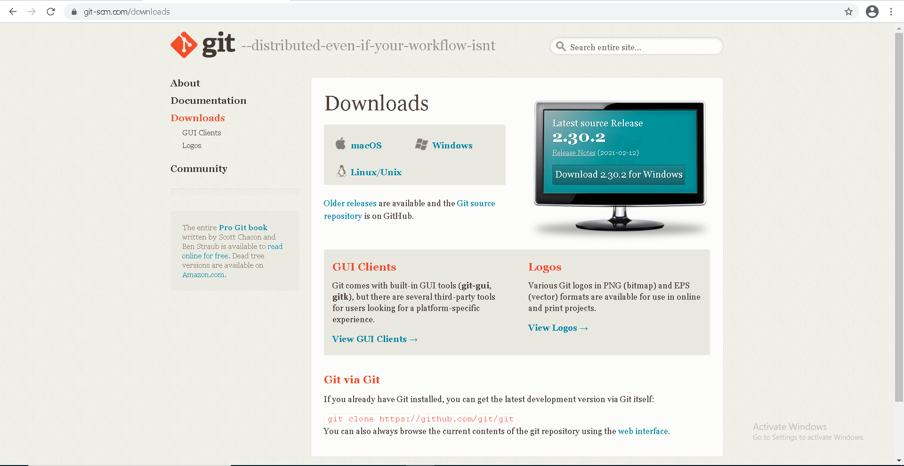
Step 2: Once it is downloaded open and start installation.  Click the next button until it asks for the editor you would like to use for git, you can choose any I prefer to choose “Use Visual Studio Code as Git’s default editor”. Hit the next button | 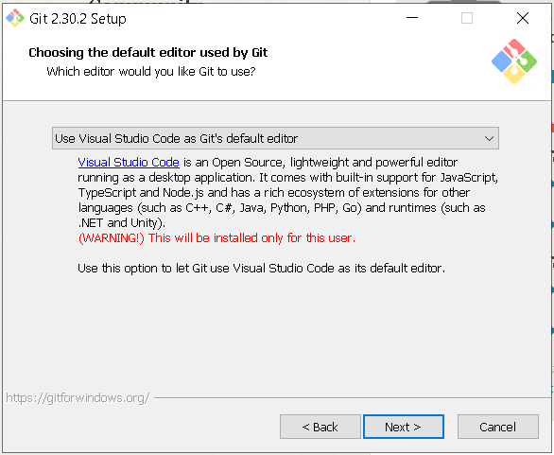
Step 3: hit the next button and let every setting for git be default as preselected. Once you get everything done, click install.
Step 4: once the installation is done click finish. | 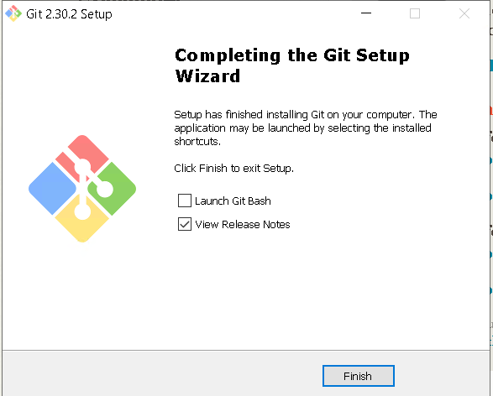

Now head over to GitHub.com and be sure to check out their help pages after signing up.
Once you are signed up create a new repository and name it PowerShell_Script as we are using it for our first PowerShell script we made. Make the repository public and hit create repository. | 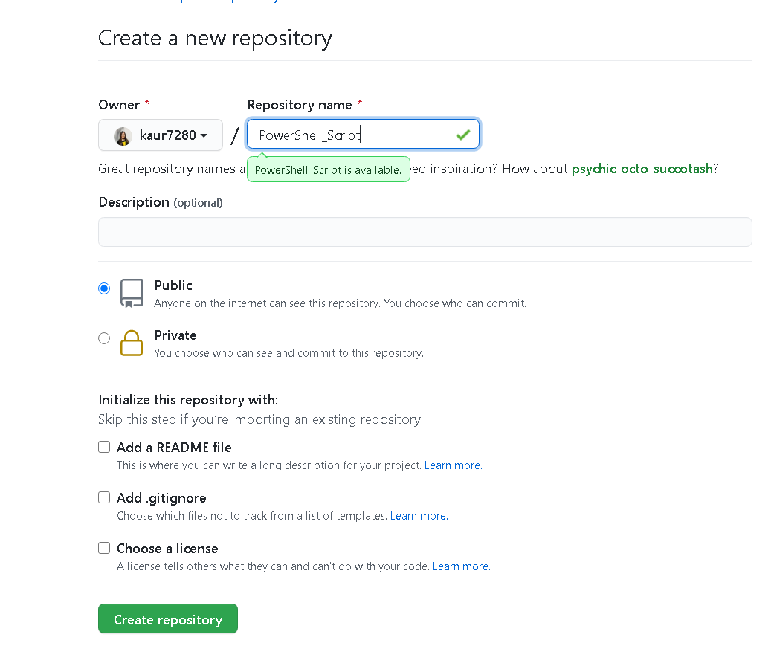
Copy the link for your repository from here. | 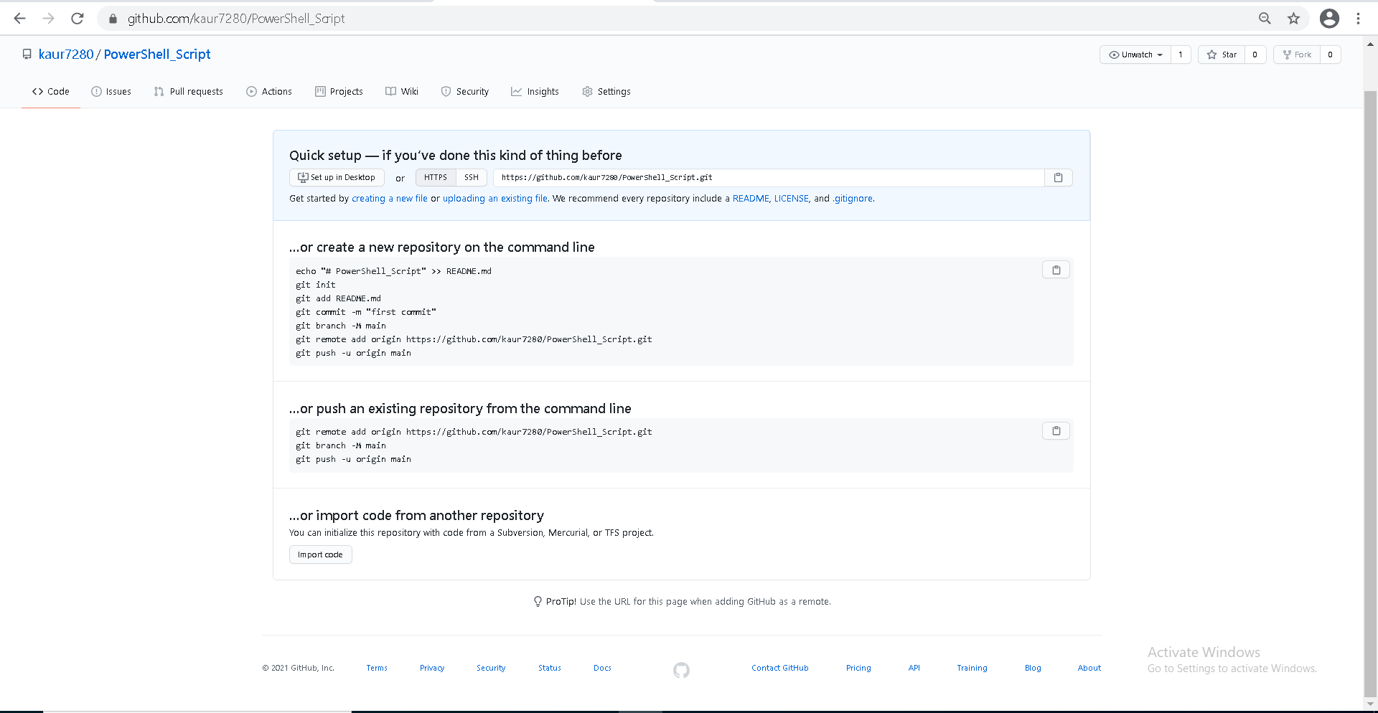
Open VS Code, go to settings and type in git enabled check if the Git-Enabled check box is marked. | 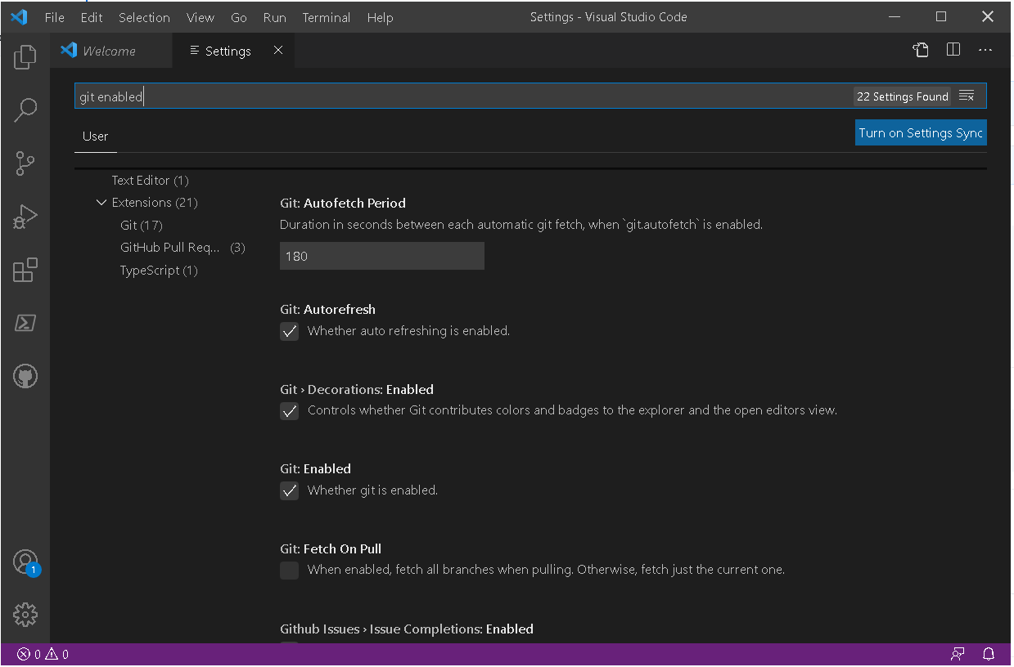
Add GitHub pull request and issues extension on your VS Code from extensions. Once its installed you can see the icon for GitHub in the activity bar. | 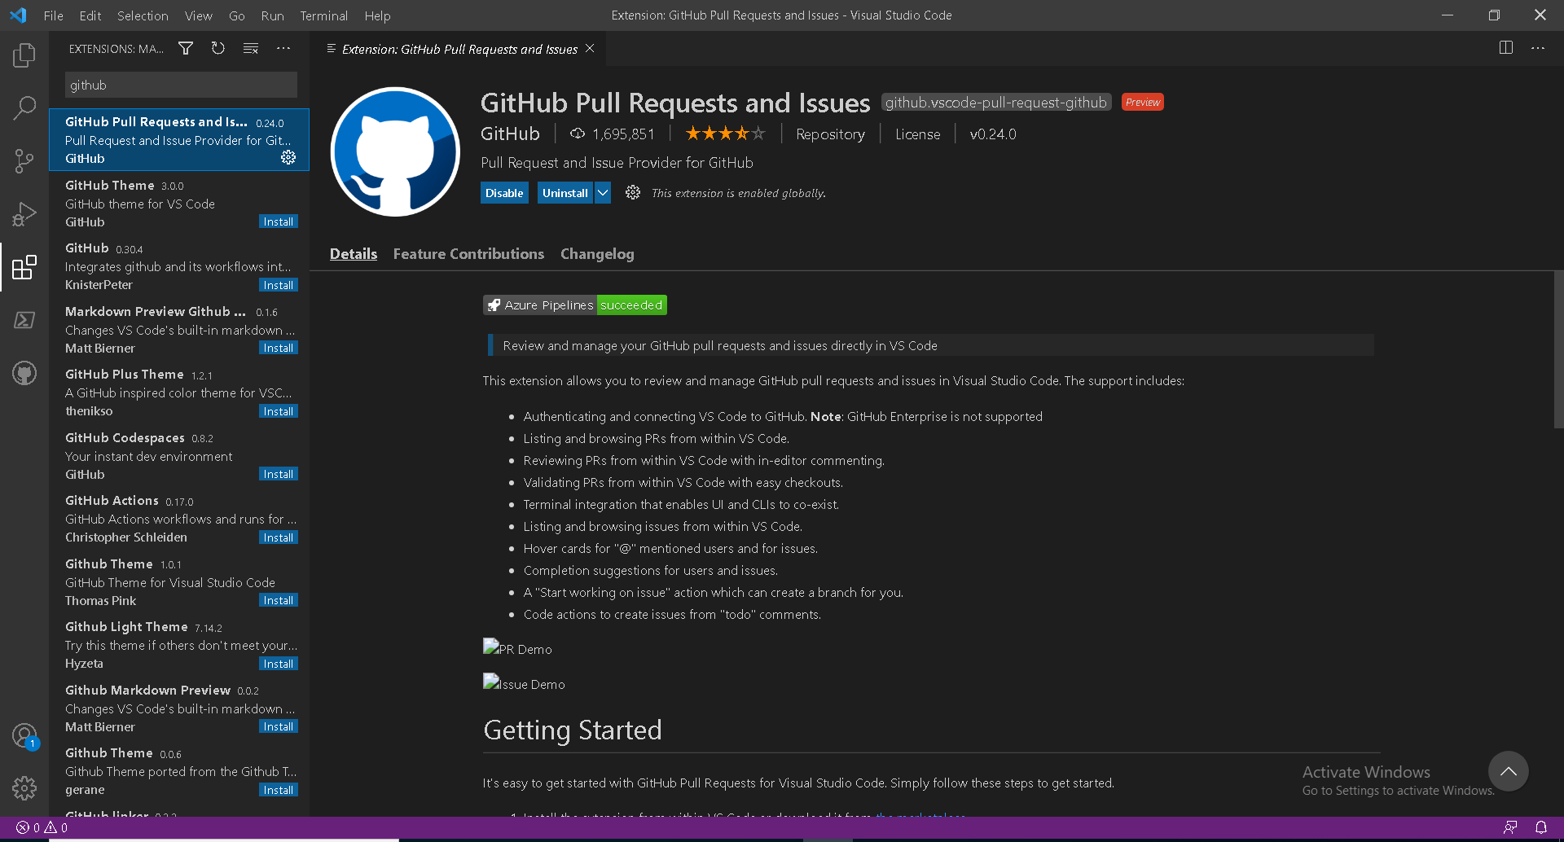
Click on the clone repository, it will ask to clone from GitHub. It will ask for the permission for the extension GitHub to sign in using GitHub, click allow then click continue. | 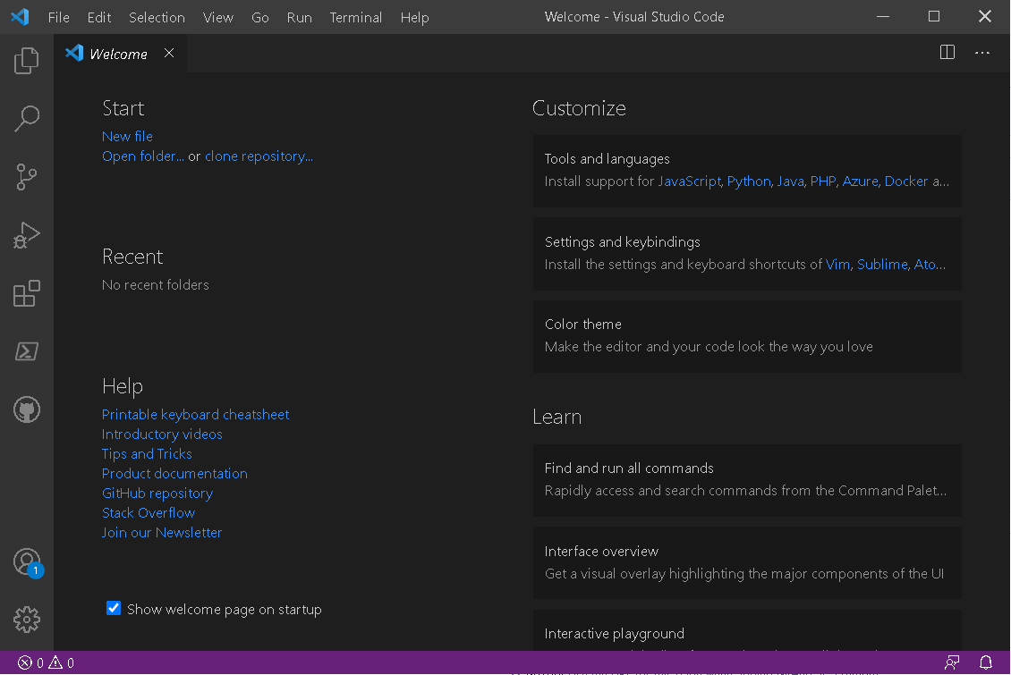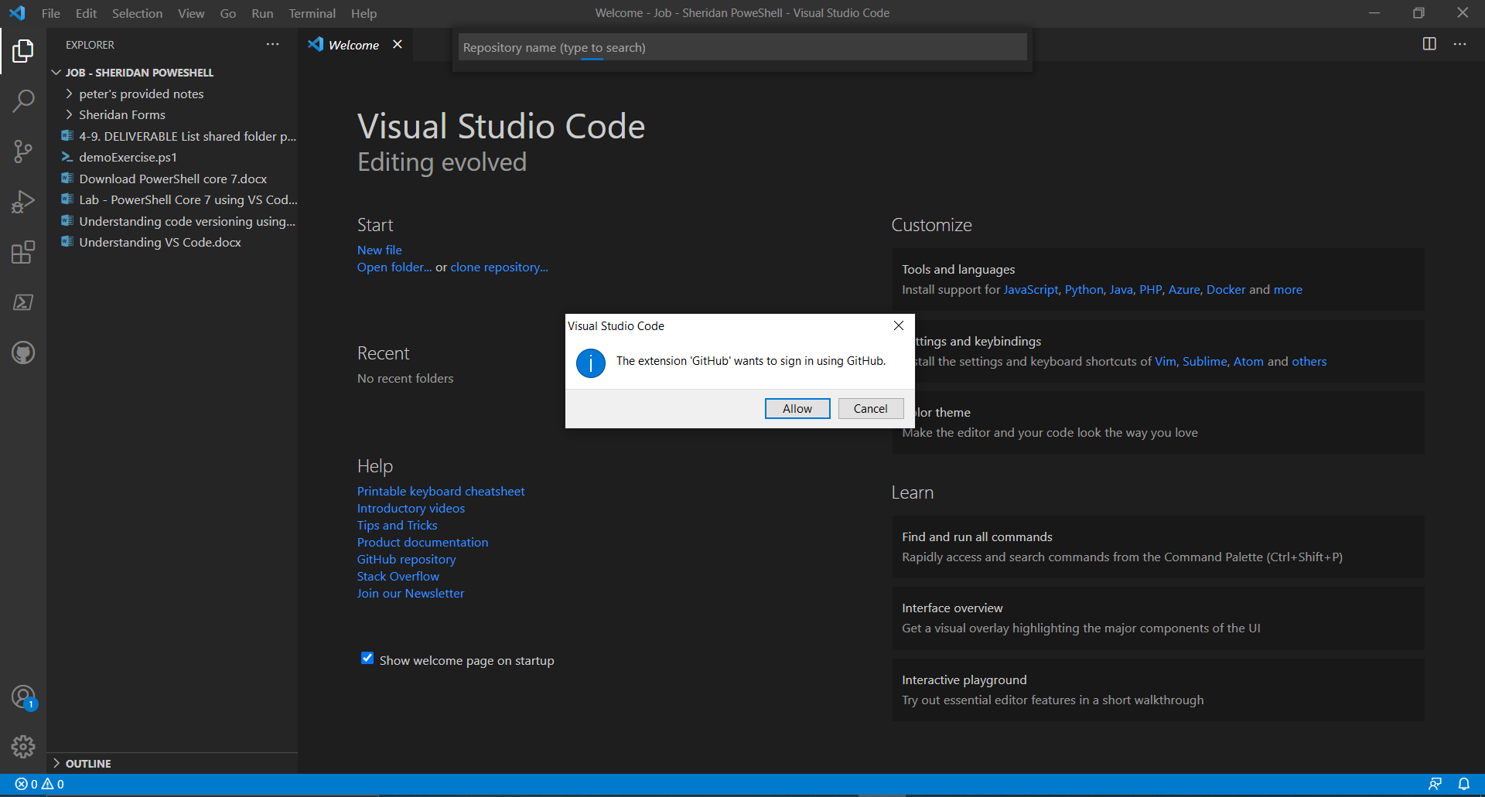
Click open | 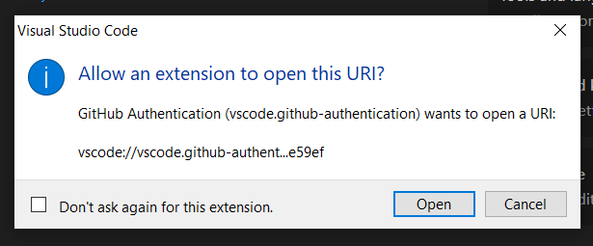
It will show you all the repositories have in your GitHub account. Select the PowerShell_Script repository we made. | 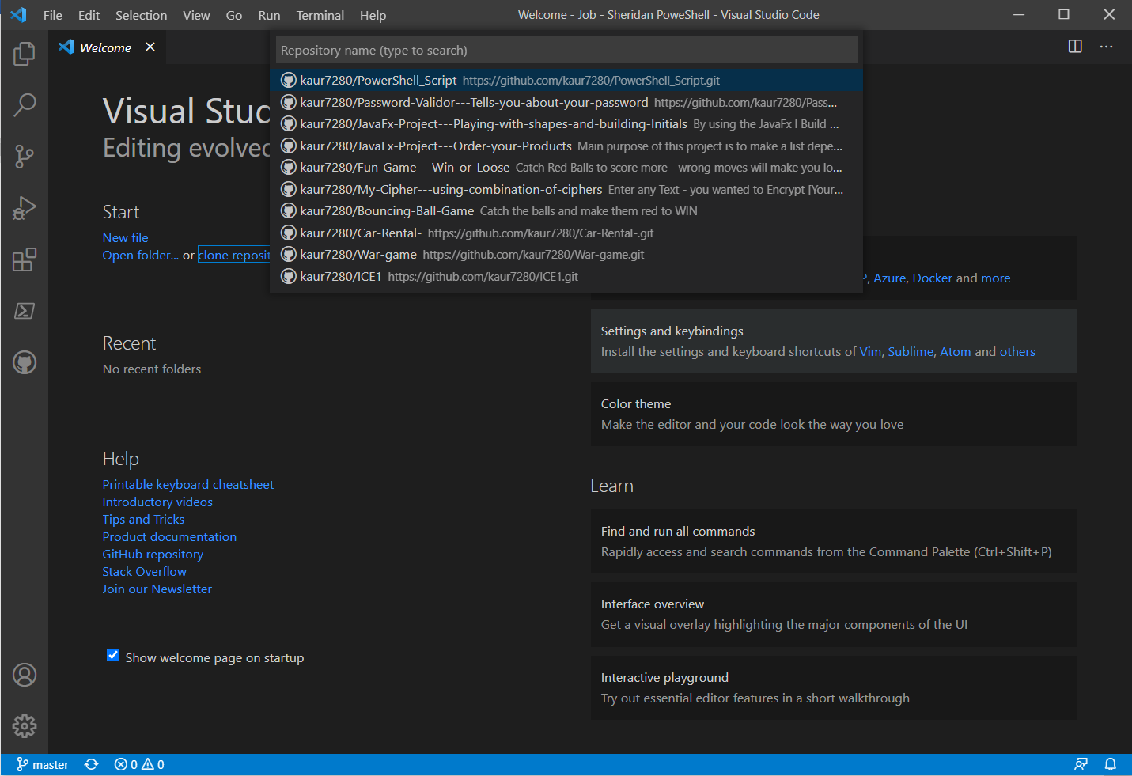
Select the desired folder to select the repository location. | 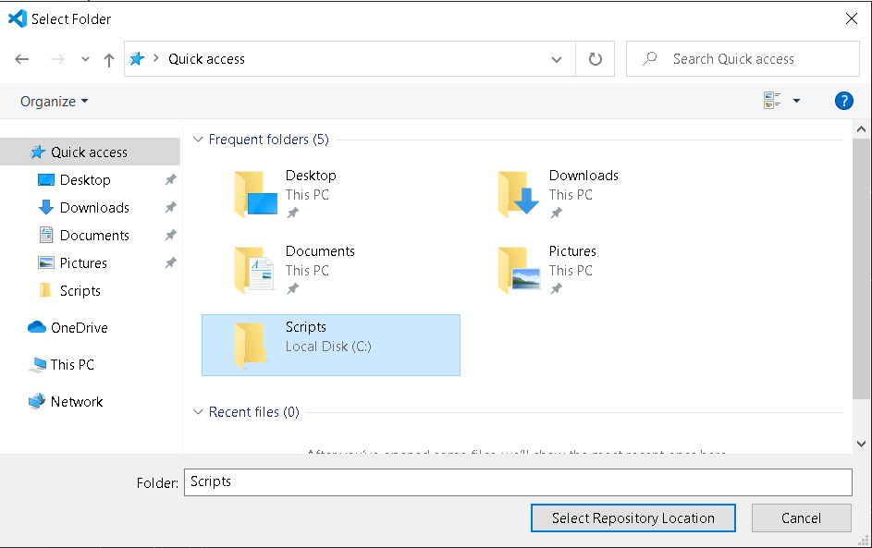
Go to the GitHub icon in activity bar and sign in with your GitHub account. Allow and continue to every confirmation warning and it will open your repository. | 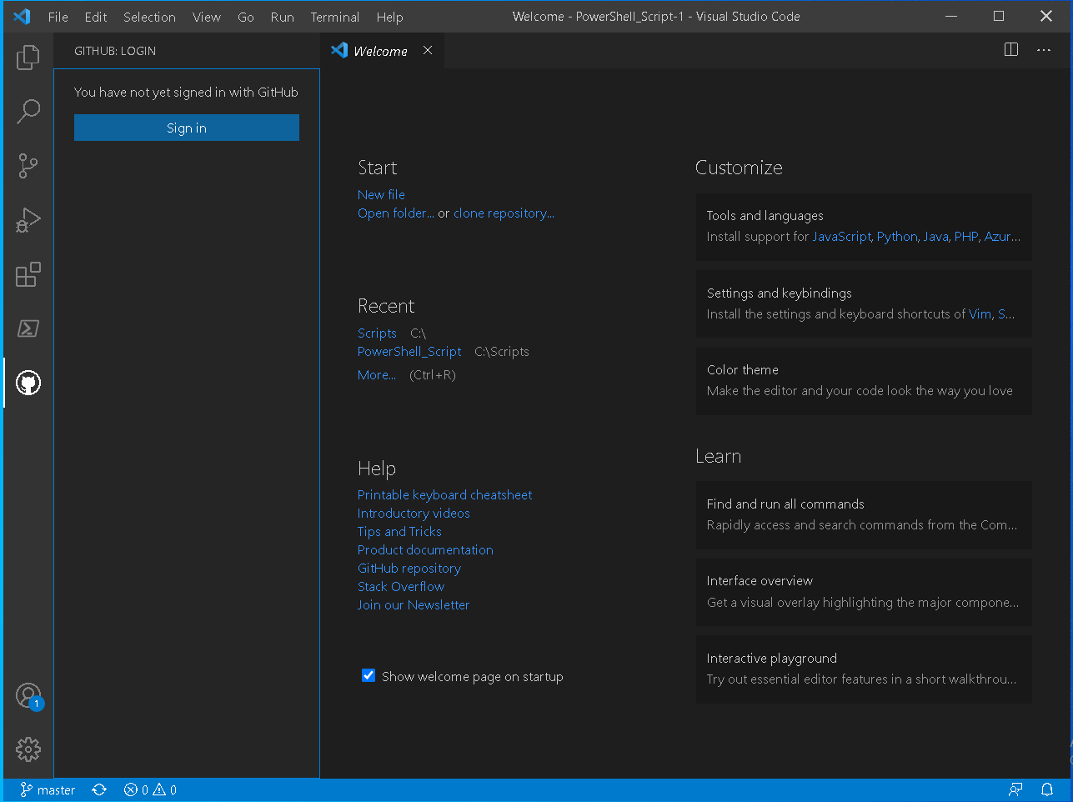
Click on file and open the folder in which our MyFirstScript.ps1 is saved. Then click on the git icon in activity bar. | 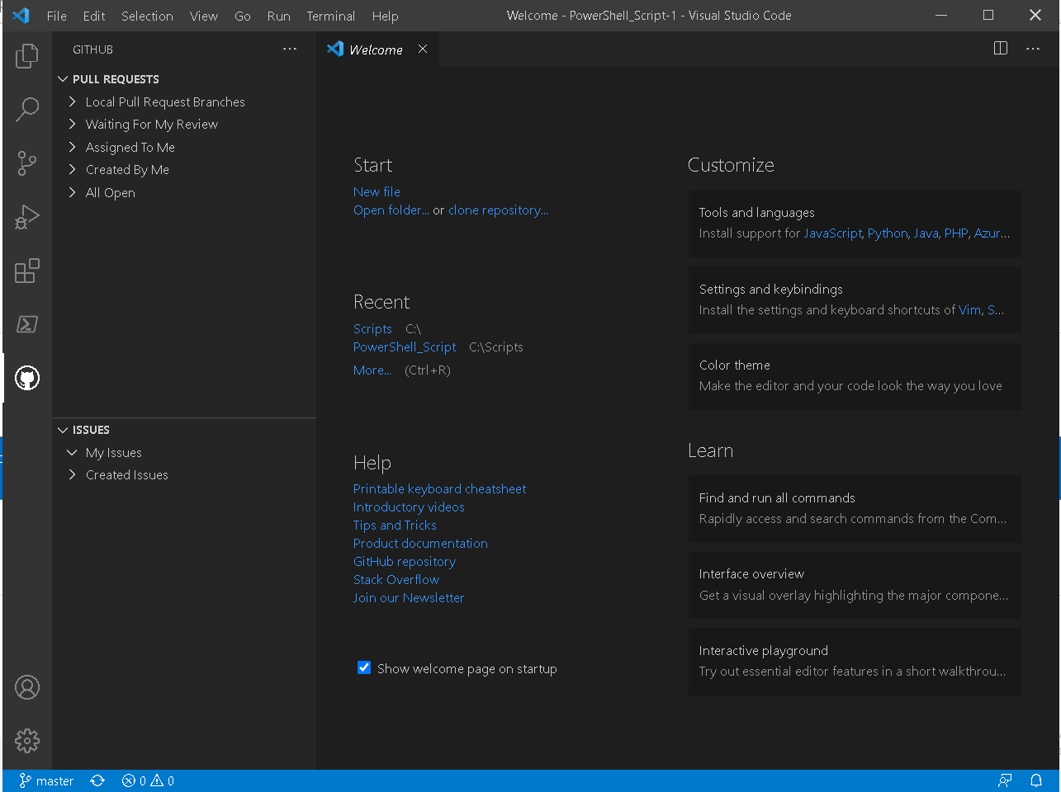
Open the folder that you choose for the repository location and check there a new folder is created as your repository name. Drag your “.ps1” file here. Now open a file on VS Code from our new location and expand source control. | 